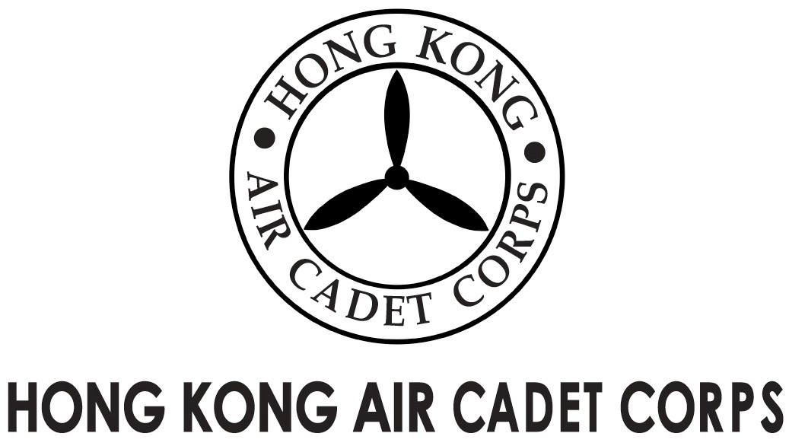
ADMINISTRATION AND SUPPORT GROUP.

From | OC PA Flt  Saki L W LEE  (sakilee0906@gmail.com) | To  Copy to | OC No. 102, No. 103, No. 403, No. 407, No. 501, No. 505, No. 6Wg  Major Unit Commanders
Our Ref | GOSA/2016/2 | # of Pages | 1
Date | 8-Dec-2016 | Your Ref

Grantham Uniformed Youth Groups Outstanding Service Award
葛量洪青少年制服團隊傑出服務獎
Invitation for Interviews

Please take note that the following cadets nominated for the caption award are invited to attend an interview at Josey Room of Aviation Club on 10-Dec-2016 (Saturday).

Rank and Name Interview Time
FS KAN Hei Tung 1000 - 1015 hrs
Cpl TSO Sze Ming 1015 - 1030 hrs
Cpl MOK Chun Yiu Jonathan 1030 - 1045 hrs
Cpl TAM Shing Ho Alan 1045 - 1100 hrs
FS CHU Wang Chun 1100 - 1115 hrs
CWO WONG Hin-chung 1115 - 1130 hrs
Cpl CHENG Wun Kiu 1130 - 1145 hrs

The dress code is No.2A or 2B. Please report to the venue 10 minutes before your allotted time.

Yours sincerely,

Saki L W LEE
Flying Officer OC PA Flt

